Stage 4 – They’re eating the dogs!
COURSE DESIGNER: Ryan Christenson
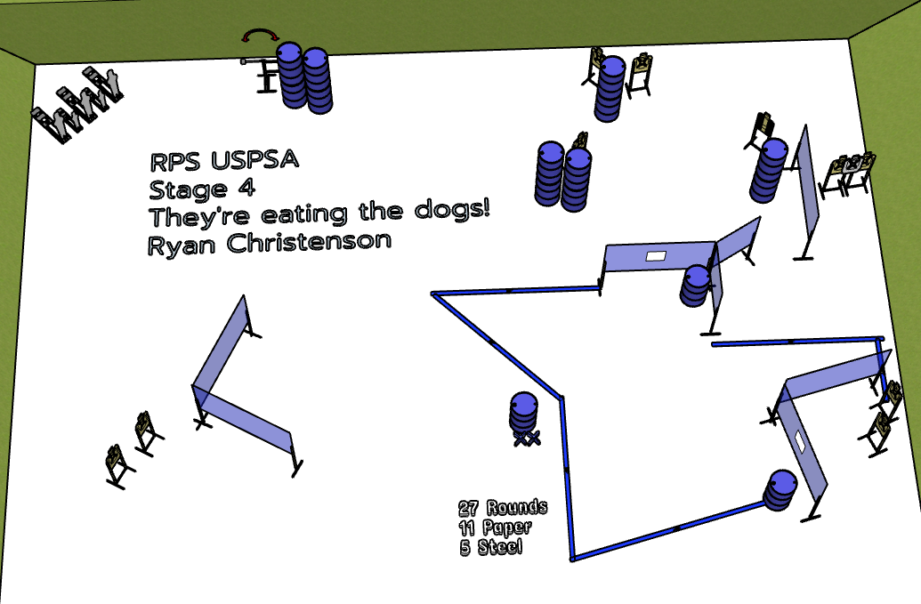

Written Stage Briefing:
Stage 4 – They’re eating the dogs! - is a 27 round, 135 point, Comstock course. There are 11 cardboard targets and 5 steel targets. The best 2 hits per cardboard target will be scored. The steel must fall to score.
Start position is both feet on the Shooting Sports Innovations Xs.
Handgun unloaded and holstered, wrists below belt.
PCC unloaded, stock on belt.
All magazines / reloading devices to be used on the stage must be placed on a barrel prior to the start signal and may not be stored on the shooter after the start signal.
The port must be closed prior to the start signal.

Setup Notes:
9 Single Wall Stands
2 Double Wall Stands
1 Triple Wall Stand
4 Full Walls – 1 Full Port - 1 Drop Port Wall - 2 Half Walls
10 Target stands / 20 target sticks
1 Swinger and activation cables
4 Poppers and Bases
1 Activator Popper
1 Starting Xs
16+ barrels


